Assignment 4

Name : Shyam Nagnath Lokhande

Class : TE COMP

Roll NO : 036

Batch : t1

**Title:** GUI for screen complexity

**Problem Statement:** To Redesign Existing Graphical User Interface with screen complexity

## Learning Objectives:

* To study principles of Good screen design
* To apply the screen complexity rules to a GUI to improvise it.
* To analyze the human considerations in Interface and screen design.

## Learning Outcomes:

* Design better screens in interfaces based on visually pleasing structure
* Learn to organize the elements on an interface screen by properly calculating the screen complexity.
* Learning the factors that affect the screen design quality with respect to user expectations

## Requirements:

Any GUI screen from a selected application.

General structure of the elements on the screen to measure complexity factors.

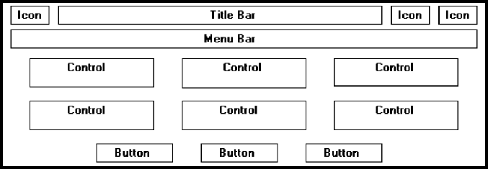

To calculate the complexity first determine the following:

1. the number of elements on the screen : ----------
2. the number of horizontal (column) alignment points: ----------
3. ) the number of vertical (row) alignment points: ---------
4. Total:
5. Complexity:

An example is given below:

Existing Design: Students need to draw the existing design for the selected page/app.

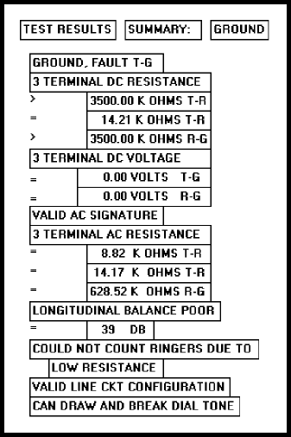

## Original Design of the GUI

In the above screen the elements are not placed in a proper symmetry, which creates user confusion and loss of interest in the interface.

* The first requirement is to identify the text boxes and their places on the screen and then place them in a proper order , also group them as per requirement.
* The re-designed screen for the above example is shown in the figure below.
* To validate the improved screen, complexity of the screen is calculated which shows the optimization of screen space as well as the user friendly interface.

Recreated Design: Students need to redesign the existing design for the selected page/app with better complexity

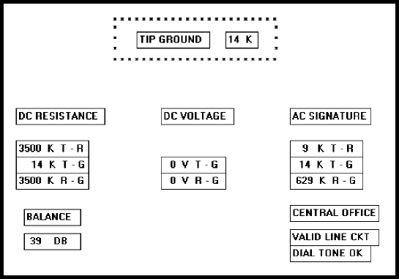

## Re-designed Screen design

**Calculation of complexity:**

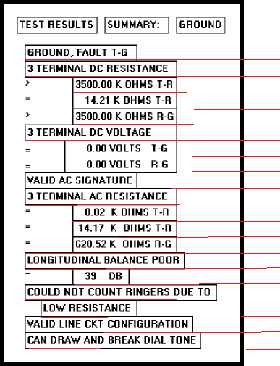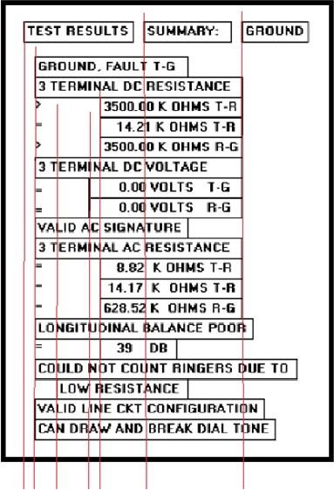

# Calculate Screen Complexity:

**Original Design**

1. 24 elements
2. 16 horizontal (column) alignment points
3. 10 vertical (row) alignment points
4. Total = 40

m

1. **V_Complexity** = - N ∑ PnLog2 Pn ;where Pn= ( Vertical Element Cut / Total)

n=1

= **96**

m

**H_Complexity** = - N ∑ PnLog2 Pn ;where Pn= ( Horizontal point Element Cut / Total)

n=1

= **51**

**Total Complexity** = V_Complexity + H_Complexity

= 96+51

**= 147**

**Redesigned Screen**

1. 12 elements
2. 10 horizontal (column) alignment points
3. 7 vertical (row) alignment points
4. 27 Total

m

1. **V_Complexity** = - N ∑ PnLog2 Pn ; where Pn= ( Vertical Element Cut / Total)

n=1

= **28**

m

**H_Complexity** = - N ∑ PnLog2 Pn ; where Pn= ( Horizontal Element Cut / Total)

n=1

= **47**

**Total Complexity** = **V_Complexity + H_Complexity (Bits)**

= **28+47**

= **75**

**Output:**

**Existing GUI- More complexity**



# Redesigned GUI - Less complexity

**g**

**Conclusion:**

Thus we have successfully redesigned the existing GUI and reduced the complexity by re-arranging the elements of the existing GUI.